Effaith Ffotodrydanol.

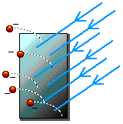

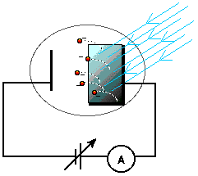

E = h f

h f = EC + W
EC = h f - W
h f = EC_{max} + W_{o}

W_{o} = h f₀

KE_{max} = h f - W_{o}
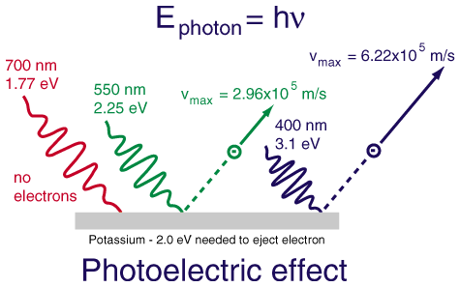

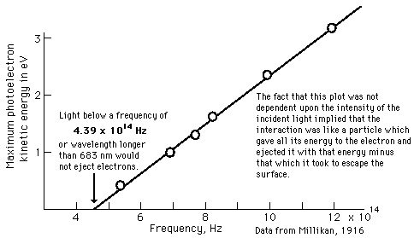

EC_{macs} = eV_{s}
EC_{macs} = hf – W
Felly: graddiant = h, W = croesdoriad yr echelin y

